SCCM HealthCheck Scripts

Workflow and Technical Reference

David M. Stein, En Pointe Technologies, a PCM Company

Updated: 4/12/2017

# Overview

The SCCM Health Check package contains scripts, support files and configuration settings to extract and compile a health assessment report for an SCCM site. It relies on PowerShell v4 or later, and works in three (3) phases: Data Collection, Reporting, and Final Analysis.

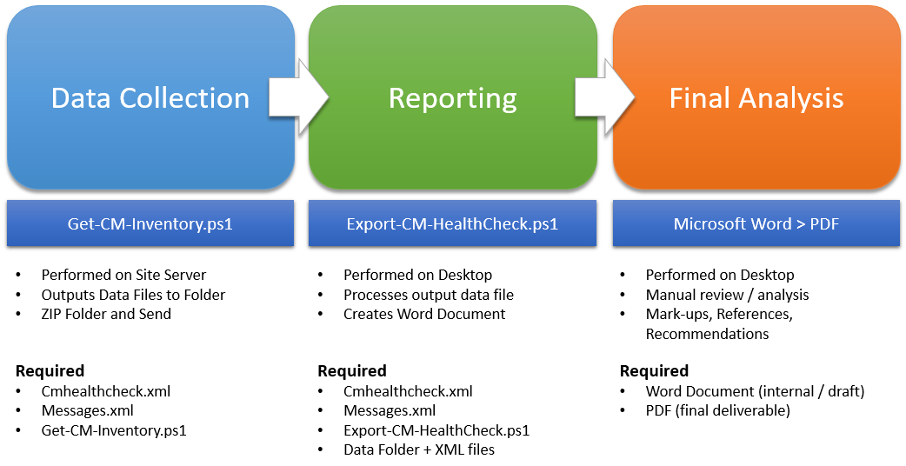

The Data Collection phase is performed on the top-level SCCM site server in a given hierarchy. The PowerShell script must be executed under the context of a full administrator in all of the associated platforms:

* Windows Server operating system
* Configuration Manager site hierarchy
* SQL Server instances

When used in a hierarchy which includes multiple AD Forests, you may encounter issues with the script if there are obstructions resulting from insufficient trust permissions, firewall port allowances or stopped services such as WMI and Remote Registry.

# Revision History

|  |  |  |
| --- | --- | --- |
| Revision | Description | Owner |
| 0.4.0 | First upload to repository. | DS |
| 0.5.0 | Feature enhancements, bug fixes | DS |
|  |  |  |

# Setup

Note: The first step (Data Collection) only requires a subset of the files in order to process the collection. This includes the files “cmhealthcheck.xml”, “messages.xml” and “Get-CM-Inventory.ps1”

While logged onto the SCCM top-level site server (direct, or remotely)…

1. Create a folder to extract the script and support files into
2. Open a PowerShell console via Right-click > “Run as Administrator”
3. Change the working folder to the script folder location
4. Invoke the script with the -SmsProvider parameter assigned to the site server FQDN.

# Usage

When the script is finished, it will create two folders beneath the source folder. One named “_Logs” and the other will use the current date (e.g. “2017-04-12”). Beneath the date-named folder, will be a folder named for the SmsProvider (servername), which contains all of the collected data files.

# Report Generation

ZIP the date-named folder and all sub-folder content and copy to a computer which has Microsoft Office installed (2010 or later, 2016 is recommended). The target computer must run Windows 7 or later, and requires PowerShell v3 or later (recommend Windows 10 with PowerShell 5.x).

Note: The export process requires a different subset of files from the package: “cmhealthcheck.xml”, “messages.xml”, “CMHealthCheck.psm1”, and “Export-CM-Healthcheck.ps1”. These files need to be extracted to a folder on the target computer. The data ZIP file should be extracted into that same folder so that it creates the same sub-folder structure as the original (for example, “C:\HC”, “C:\HC\_Logs”, etc.)

1. Open a PowerShell console
2. Change to the folder where the script files reside
3. Execute the “Export-CM-Healthcheck.ps1” script with the -ReportFolder parameter assigned to the path of the date-named folder (example “.\2017-04-12\cm01.contoso.com”) along with other parameters (see Parameters below)
4. The script will open Microsoft Word and begin building the report. This may take anywhere from 10 minutes to an hour, depending upon the amount of data collected.

# Parameters

The following section explains the required and optional parameters for each of the PowerShell scripts.

## Get-CM-Inventory.ps1

### SmsProvider

[required] (string) The (FQDN or NetBIOS) name of the SCCM site server to query.

### NumberOfDays

[optional] (integer) The number of days prior to the current date from which to limit the collection of event data from the site server database. The default is 7.

### HealthCheckFilename

[optional] (string) The name of the XML file which provides the configuration defaults for the collection process. The default is “cmhealthcheck.xml”

### HealthCheckDebug

[optional] (switch) Enables additional verbose output to both the console and the process log file. You can combine this parameter with -Verbose to provide complete detailed output during processing if desired.

### OverWrite

[optional] (switch) Enables the collection process to replace existing data files, if a collection process has been performed against the same site server, on the same date. The default is <false> which will cause an error to occur if a collision is detected.

### Examples

**.\Get-CM-Inventory.ps1 -SmsProvider "cm01.contoso.com"**

**.\Get-CM-Inventory.ps1 -SmsProvider "cm01.contoso.com" -HealthCheckDebug:$True**

* verbose execution, showing all details

## Export-CM-HealthCheck.ps1

### ReportFolder

[required] (string) The name (or full path) of the data collection folder. If the script is executed from a folder such as “C:\HC” and the data folder is under “C:\HC\2017-04-12\cm01.contoso.com”, the parameter value can be specified as “.\2017-04-12\cm01.contoso.com”

### Detailed

[switch] (optional) If specified, results in a highly-detailed report file. Without this parameter, only a brief summary report is created. The default is <false> or <off>.

### HealthcheckFilename

[optional] (string) The name of the XML file which provides the configuration defaults for the collection process. The default is “cmhealthcheck.xml”

### HealthcheckDebug

[optional] (switch) Enables additional verbose output to both the console and the process log file. You can combine this parameter with -Verbose to provide complete detailed output during processing if desired.

### CoverPage

[optional] (string) The name of the Microsoft Word template Cover Page to insert as the front page of the report. The default is “Slice (Lite)”.

Note: This setting should be standardized across all deliverables if possible. Other Cover Page options can be previewed in Word by selecting the “Insert” tab of the ribbon menu, and selecting the “Cover Page” pop-up menu at top-left.

### CustomerName

[optional] (string) The name of the customer for which the report is being produced. The default is “Company”. This should be replaced with the actual customer name.

### AuthorName

[optional] (string) The name of the consultant/engineer performing the analysis. The default is “Author”. This should be replaced with the actual customer name.

### CompanyName

[optional] (string) The name of the consultant/engineer’s company providing the report to the customer. The default is “En Pointe Technologies, a PCM Company”.

### Overwrite

[optional] (switch) Enables the collection process to replace existing data files, if a collection process has been performed against the same site server, on the same date. The default is <false> which will cause an error to occur if a collision is detected.

### Examples

**.\Export-CM-Healthcheck.ps1 -ReportFolder “.\2017-04-07\cm01.contoso.com” -Detailed -CustomerName “Contoso” -AuthorName “John Doe” -Overwrite**

The _Logs folder contains the runtime diagnostics information, which can be useful when problems are encountered during the export process.

The YYYY-MM-DD folder contains the names of SCCM site servers analyzed for export. The files within the site server name folder are the raw data exports which are used to compile the final document. Using the example show in the figure above, the export date indicates May 9, 2016, and the SCCM site server is cm1.contoso.com.

# Support / Feedback

For questions, concerns, bug reports, feature requests, please contact David Stein ([david.stein@enpointe.com](mailto:david.stein@enpointe.com))